Uniting for success and for a better future
Uniting for success for a better future
Our collective efforts after months of campaigning have yielded significant achievements for consultants in England:
- major changes to AA and LTA to ensure NHS pensions are taxed fairly
- a new and improved pay deal
- vital reforms to the pay review body
Rest assured, we won't be complacent about the future, and neither should you. We must and will protect these hard won rights and we can only make further progress with your support and active involvement.
Our success stems from our strength in numbers and your actions, the fight continues – now is the time to make sure you continue to be part of it.

Consultants in England accept latest Government offer on pay and DDRB reform
After months of unprecedented industrial action and campaigning, months of negotiations, and weeks of voting by BMA members, the consultants committee has accepted the latest Government offer on pay for consultants in England. Additionally, the offer includes significant reform to the Doctors’ and Dentists’ Pay Review Body (DDRB). This is an important first step on the road to restoring the value of our pay and pensions.
Eligible BMA consultant members voted 83% (turnout 62%) to accept the offer, delivering a vital first step on our journey to restored pay.

The latest Government offer on pay and DDRB reform
The new deal builds upon what was previously offered from Government and delivers some significant improvements.

Changes to pay
The new pay deal addresses member concerns that too many consultants would have been left without an immediate uplift to pensionable pay in the previous offer. The deal builds on changes to the consultant pay scale in the original offer and now includes a 2.85% (£3,000) consolidated uplift for those who have been consultants between four and seven years.
As pay for those who have been consultants for three years has not been further uplifted, this will therefore create an additional pay point. Progression to this new pay point will however be automatic (with no need for a pay progression meeting).
The pay elements of the new deal will be applied in coming months and backdated to 1 March 2024.
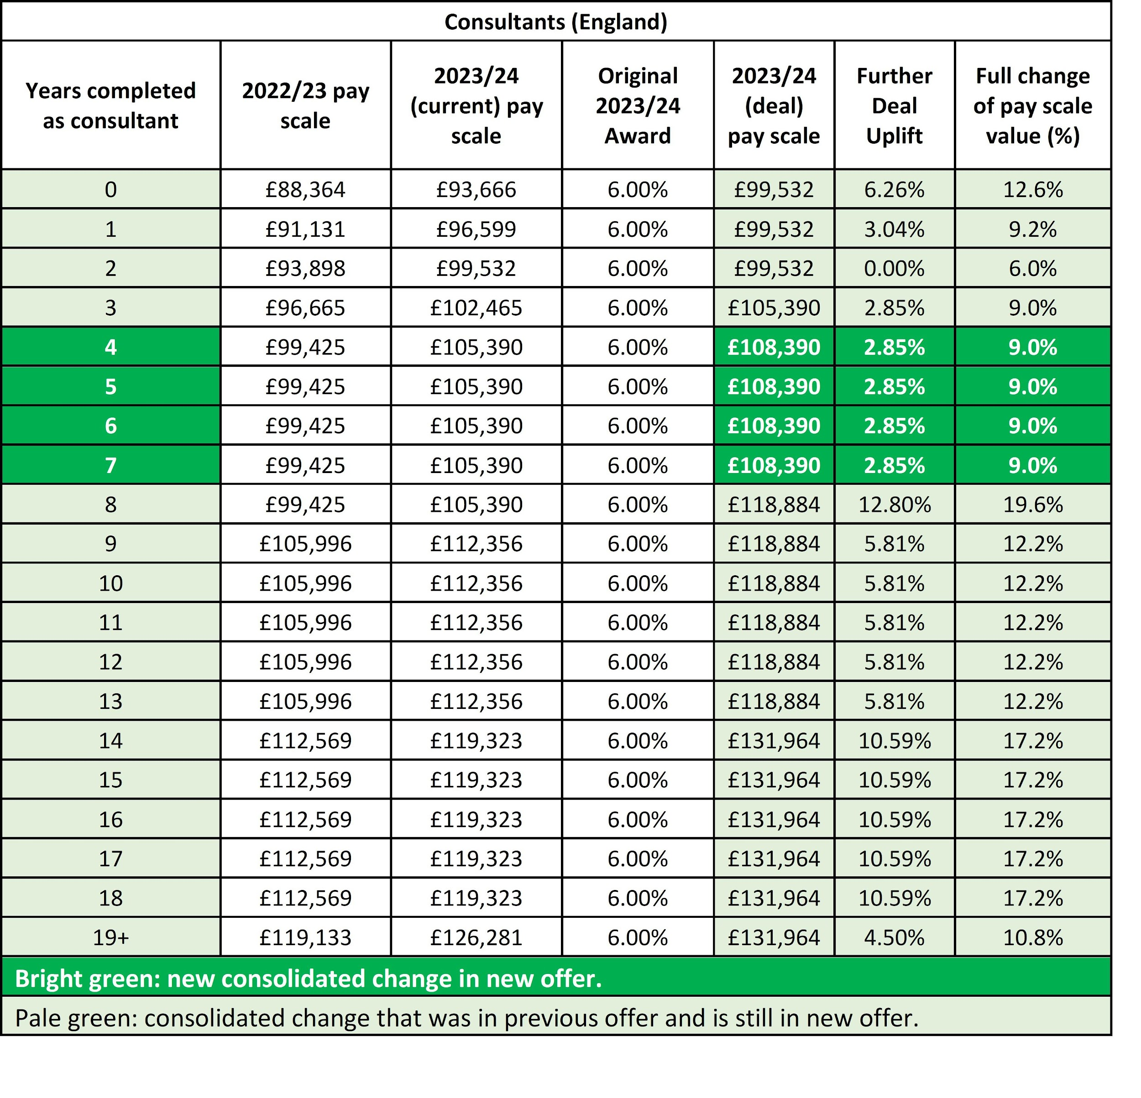
Consultants in England new offer table
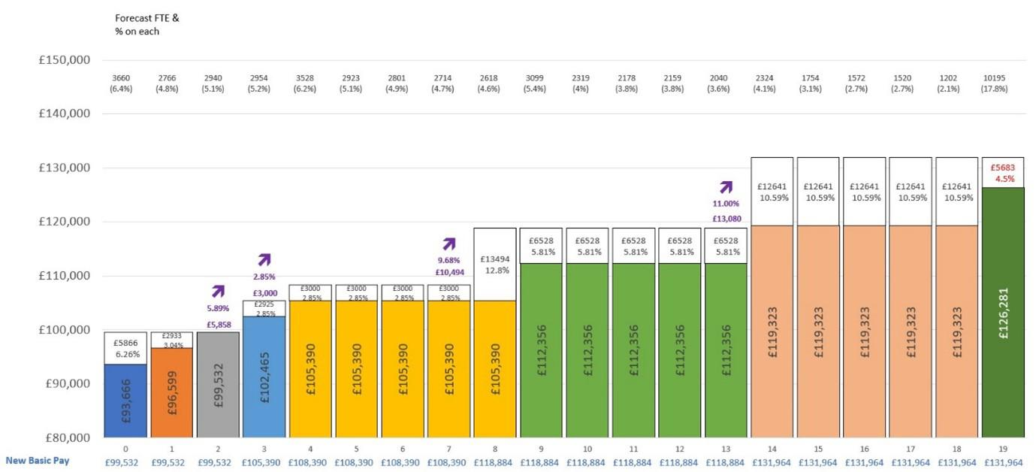
Consultants in England new offer graph

Pay body reform
The process for appointing DDRB members will now allow for greater input by the BMA and other trade unions. Relevant unions will be invited to work collaboratively with the Government to prepare job specifications and be part of the panel during the sifting stage of the recruitment process. The Government has restated that DDRB members must be people of eminence and authority and has committed to increasing the remuneration for DDRB members and advertising more widely to ensure that it attracts the best calibre of appointee.
There have been significant changes to the terms of reference that guide their recommendations. Firstly, it will be clear that the DDRB must have regard to changes in doctors pay over the years in the context of long-term trends in the wider labour, as well as considering comparator professions including relevant international comparators. This is key as the DDRB will no longer be able to ignore what has happened to our pay in past when making recommendations.
Secondly, the DDRB will need to consider each factor within its terms of reference separately and not allow one feature to override others. This is important: when reading previous DDRB reports, they give the impression that while they recognise that pay has fallen both over time and against comparators, this was ignored because other features, such as a blunt assessment of recruitment and retention and the Government's position on affordability, dominated. With these changes the DDRB will need to have regard for each of the factors separately without them being contingent on each other.
Thirdly, it has been clarified that the Government cannot constrain the DDRB by including information about affordability its remit and instead should confine this information within its own evidence.
These DDRB reforms will be in place for the 2025/26 round. This is the first meaningful reforms to the DDRB since 1998 and aim to ensure that the DDRB has much greater independence and the power to make fair recommendations on doctors pay.

